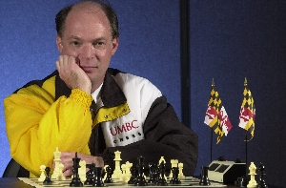

Dr. Alan T. Sherman, Director UMBC Chess Program

Dr. Sherman has been the Director of the UMBC Chess Program since 1991. Under his leadership UMBC has won (or tied for first place) at seven Pan-Am’s (96, 98-02, 05) and four President’s Cups (03-06)—more than for any other college in the history of college chess. Sherman organized the 1996 Pan-Am in Baltimore and the 2006 Pan-Am in Washington, DC. He won the top faculty prize at five Pan-Am Opens (98-99, 01, 03-04). Sherman earned his PhD from MIT in computer science in 1987. As Associate Professor of Computer Science, his main research interest is high-integrity voting systems.

